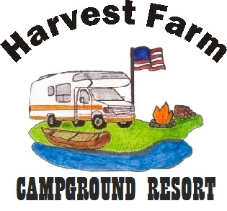
Harvest Farm Campground Resort, L.L.C.
wecamp@harvestfarmcampground.com
3690 318 Ave; Cresco, IA 52136
www.wecamp.com
563.883.8562

NEW Seasonal Site Application

Type in the fields to complete the form below and submit it to Harvest Farm Campground Resort.
You can either attach it to an email message or mail it-- to one of the addresses above.

Name Spouse

Street Address

City / State / Zip / /

Phone (cell) (work/home) / Cell/spouse

E-mail E-mail/spouse

Year of Birth Marital Status How many kids under 18?

Retired
Employed Occupation Place of Employment

Year applying for

Tell us about yourself

How did you hear about us?

Why do you want a seasonal site at HFCR?

What type of camper do you own?

Do you know any current seasonal site campers?

Who?

Anything you want us to know?

Thanks for the opportunity. We look forward to camping with you.
Dave

David Ferrie
Campground Manager

